Photo requirements for Indian visa
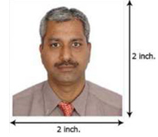
1 - 1-3/8 inch.
1- 1/8 inches to 1-3

- The photograph should be in color and of the size of 2 inch x 2 inch (50 mm x 50 mm).
- The photo-print should be clear and with a continuous-tone quality.
- It should have full face, front view, eyes open. Photo should present full head from top of hair to bottom of chin.
- Center head within frame.
- The background should be a plain light colored background.
- There should not be any distracting shadows on the face or on the background.
- Head coverings are not permitted except for religious reasons, but the facial features from bottom of chin to top of forehead and both edges of the face must be clearly shown.
- The expression on the face should look natural.
- Make sure photo presents full head from top of hair to bottom of chin; height of head should measure 1 inch to 1-3/8 inches (25 mm to 35 mm). Make sure eye height is between 1- 1/8 inches to 1-3.

